Mid-term GitHub project

* Building a 1-page app (with image and text)
* Pick a subject that you can disagree with
* Divide the page into two sections, first is arguing for, the second section is against.
* Create conflict and resolve it.
* Create GitHub repo with Readme file (basic introduction)
* Branch; push the project.

<Roy> - Debater A

Topic: Pineapple Bun is the most iconic food in Hong Kong

The history of Pineapple Bun: Pineapple buns are a Hong Kong bakery classic – a fluffy, milk bread-based bun topped with a crackly, crunchy cookie topping. The name pineapple bun doesn’t come from any pineapple additions to the bun but its shape.

Highlight: (1) Fresh from the oven with a crispy crown that does not easily fall off.

(2) Often served warm with a thick slice of cold butter in the middle.

Additional variations include versions with custard and red bean.

　　　 (3) light, soft, and airy, with an extra crispy, buttery, and

sugary crust that cracks perfectly into a pineapple pattern.

Images: 3 needed

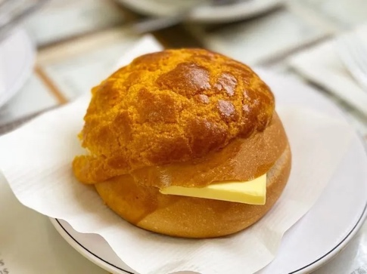

<Tina> - Debater B (Against)

I think egg tart is the best and the most iconic food in Hong Kong.

**What is egg tart (Cantonese called Daat Tart)?**

One of the world-famous pastries in Hong Kong! Hong Kong egg tart is unlike European custard tarts. It is a variation of the British custard tart. Hong Kong-style egg tarts consist of an eggy custard centre with a pastry crust. There are many bakeries and dim sum restaurants that prepare their tarts using a flaky puff pastry crust with multiple layers. However, some bakers pay homage to the tart's Western history by using a buttery shortbread crust.

**Why are egg tarts more iconic than pineapple buns?**

1. There are many coverages posted online about the last governor of the Hong Kong colonial; Chris Patten, who is obsessed with Hong Kong-style Egg Tarts. A freshly baked egg tart from his favourite bakery shop in Hong Kong was the most important thing to do before the handover. What significant evidence shows how iconic the egg tart is compared with the pineapple bun?

2. Huge number of Fans. They even make streams of graphics, stickers and merchandise based on egg tarts.

3. When you think about Egg Tart, it comes up with Hong Kong definitely. When it comes to Pineapple Buns, Hong Kong is not the first country that comes to mind, but rather other Asian countries.

4. The texture of egg tart is richer and eggy than pineapple buns, while with a small portion, you can eat more than one at a time!